Bullock Smithy Hike 1st September 2012: ‘Knotbury Nightmare’

There is a certain set of smells I associate with the Bullock Smithy. Its late summer and we pass through the countryside in the afternoon, catching the damp or dry hay filling the warm air. This year I added my own aroma by smothering legs in Deep Heat and then a layer of sun scream. A week before the race a hamstring (mine) had made itself known to such an extent that a late fitness test was required on the Friday and I gave myself a borderline pass. So race day, Saturday, was another sunny day and a hike commander was heard saying earlier in the morning he thought sun cream would be needed – not wrong. The cool 12C at 9am had risen to nearer 20C at the noon start.

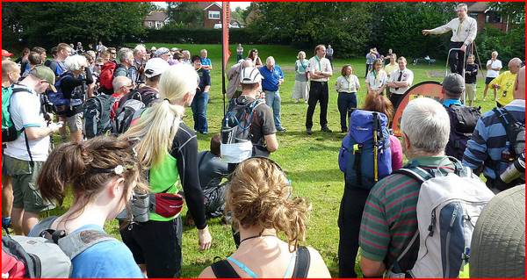
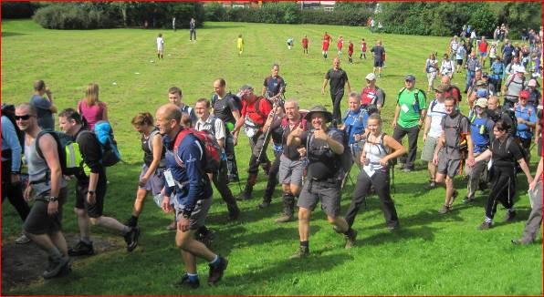

Bullock Smithy start from Devonshire Park

Now to get the hamstring warmed up; although deep heat had already kicked in; a few stretches, a jog round, a few more stretches, another jog round, a wee, a few more stretches and nearly time to start. Should I do a few more stretches? As the iconic anvil receives its hammering we set off out on to the A523, Towers Road and into the Peak District via Lyme Park. I’m thinking, coo, the hamstring is behaving and I’m running happily. Later, much later, I’ll be back along Towers Road – but much too early for such thoughts – must focus on just this first section for now. I’d let my mind run through the race visiting check points when drifting to sleep last night, but had not been able to get passed the half point – hopefully not an omen.

Now, it’s warm, and perhaps very warm, what to do about drinks? I stuck with a tactic from previous years and went with half litre between checkpoints. There was no problem drinking this much for at least half the race even with the questionable lime flavoured salts added. My pace seemed good (for me) and the regulars were around – Paul Rushworth, Steve Jackson, and Julian Brown with Steve making a fabulous start disappearing quickly into the distance. Steve Temple was at the start and I’d expect to see him come past before Edale. Paul is my normal pace maker and I stayed in touch until Jacob’s ladder where Paul put into practice his first pre-race planned ‘shortcut’. Not one of his best. However I’m left behind on the flat to Edale.

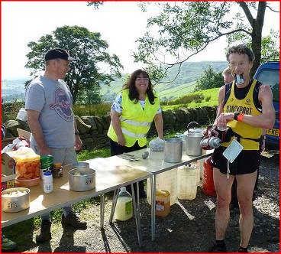
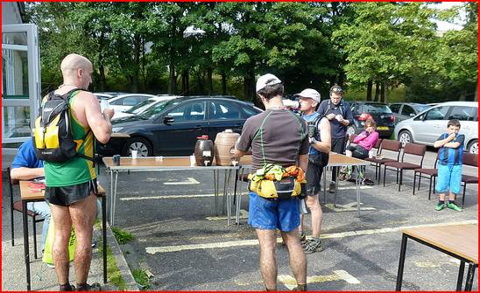

Nick Ham reaches refreshments after Chinley Churn cp Edale cp – refresh and relax outside in the sun

Edale cp reached. Full spread outside. I grab a seat, down fruit and rice, fill water bottle and off. I’m now feeling the full effects of the warm start and energy levels drop. It’s all I can do to just about keep up with a few chaps who’ve just overtaken me to Hollins Cross. I know what’s coming; the cramps are paying their first of many visits. Down to the road, and as I jog slowly I put my feet through all sorts of unnatural positions in an attempt to avoid lower leg cramp. I’m longing for off road. Jam butty (with margarine) at Castleton after Julian has passed me with his cramp advice, “plenny of flu-ids and walk t’up hill”.

A visit to Cave Dale, home of many long distance runs in this area. I wonder how Paul got on and probably many others (I’ve seen Nick’s photos) taking the steep grassy ascent instead? The inter checkpoint times show maybe it would have made a few minutes difference if I’d gone alternative – next year! There’s less run in me than usual, but once on the tops I’m inspired by the emptiness of Limestone way. I must not overstretch, just keep the pace going. The first of the many cow field crossings is empty of cows, just silage drying. In fact it takes up to near Earl Sterndale before the only cows are encountered.

With no navigation problems, a familiar route and feeling ‘not too bad’, it’s time to try and get some enjoyment out of the race. I do. There’s no one visibly around anywhere behind or in front – apart from non-hikers. Freedom. Taking care not to over stretch anything with the descent down to Peak Forest where I take on board some fruit – orange and banana - and 2 crisps, plus 500ml of water. I do now spot a hiker ahead on the road edge but he soon fades into the distance. Managing the cramps allows me to gently jog all the way to Wheston without have to use the grass verges to ease my shins. There is a cow about to give birth – I wonder if any later hikers saw the birth – or maybe mother cow waited until all hikers had gone passed!

It’s track now and cross country to Millers Dale. Sometimes when arriving at this cp the marshals have polity enquired as to my ‘state’. This year was no different, but with an added concern, perhaps because I immediately sat in a chair before they clipped my tally card. After three ‘state’ enquiries and another 500ml plus tablet I was off. They were happy that I could manage my state once they had ascertained I’d made 8 previous completions.
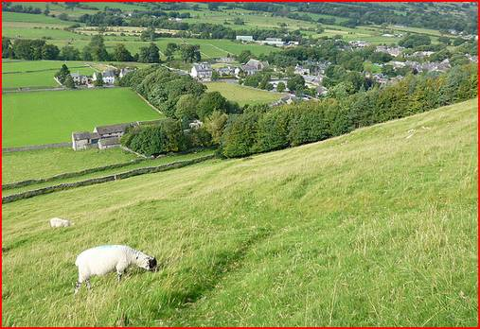
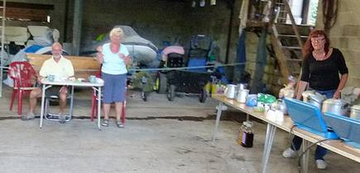

Cave Dale alternative Millers Dale cp awaits

Along then up the road at walking pace with just a few jogs. Passing some people bouldering on the huge overhangs which are just 6’ off the ground. As always there is a relief to get off this road, facing traffic descending the hill, and I was in two minds about going by track to Priestcliffe Ditch this year. I go across the fields up the track through the trees over the top and see the Chelmorton cp in the distance, a welcome sight. Joggerty jog to the cp and sit down.

I joke about a double cheeseburger, refuse the donut offer and am on my way. A level track takes us half way to Earl Sterndale, then past the quarry, over fields and soon there. Except this is where the only cows are encountered. A whole herd has congregated around the field exit gate and one of them is trying to get through the gate. I wonder how Paul managed! Thankfully a few commands of “whurshhh” is enough to move them out of the way and I’m through.

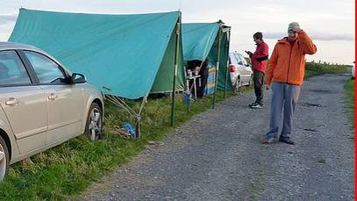
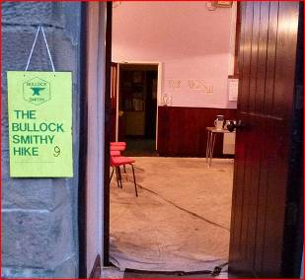
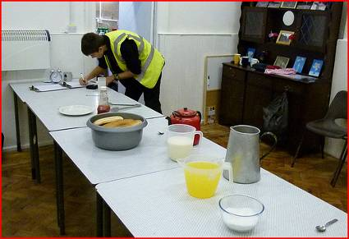
Chelmorton cp “Burgers anyone?” Cp 9: Brand Top

Earl Sterndale offers a range of jam sandwiches – with and without butter, with and without jam. I go for without and manage to munch through most of it except crusts. More familiar road and track. Memories of previous races visit me, last year Charlie had missed the turn off here down to Dowel Cave, but had recovered quickly and remainder in front of me. The temperature was dropping and a breeze made the temperature about right. However, It would be cool on the higher points later on.

No barking dogs at Brand End, just one yapping dog playing football with the young kids. These kids were looking after their property, shouting “Close the gate” to me after I’d gone passed. I did of course. Looking back I think I should have taken on more food – either at the cp (offered hot dog but refused) or my own. As I popped out of Brand Top cp a woman came in – that’s strange I thought as there had been no one behind me. I think I heard her say something to the effect that she wasn’t actually on the hike – too confusing for me to contemplate for now – I have a job in hand. That is, reach Cumberland Cottage cp before dark.

Plummet downhill and away up to Flash. Knotbury here I come. Passed the first turn, pass the second turn off. Hang on, that looks familiar, should I go up that road? I start up the second turn off. Doesn’t seem right? No one around. I get out my map, well actually maps, all over the road. To save weight this year I have the whole route on seven pieces of about A4 (should have done it double sided) which is half the weight of my previous laminated single map. But which piece is Knotbury on – it’s getting dim and my brain is fuddled – how can I not know the way after 8 times this way? Eventually the correct bit of map is found showing this second turn off is wrong. Pressing on with renewed vigour (anger) through Three Heads – lovely stream - and concentrate of the rocks/boulders then up the fields to the huge stile, except I get into the wrong field in the dim light and lose a few more minutes of duskiness. Other hikers, including leading lady Julie Gardner, appear as I’m caught and my general outlook has dropped a few points. But I make it, behind the others, to the cottage. A table is outside to clip my tally, its inside for replenishments, a sit down, and out with the head torch. Mustn’t stop in here for long – its warm, cosy and soporific.

Once down onto the lanes head torch can go off. Three of the other hikers are soon ahead and disappearing. I’m pleased to see they are going up to Macclesfield Forest as that’s my route choice this year rather than the longer, flatter, simpler, but drag of the road. A fourth hiker passes me as we leave the lanes and join the track. It’s possible to jog the whole way but in the dark with tiring limbs the excuse to walk at least some of it because the ground is slightly rough is an easy one to make. Once on the descent and back on to the lane the Walker Barn cp does not immediately show itself due to the hillside. But it is there and a few of the hikers ahead of me are just leaving it. More warm and cosy avoided here with a quick departure and the Peak District hills start to fade away as I descend – the road.

On the descent along the A537 I meet a runner (hiker) coming up the hill. Is he on the hike? I wonder if he’s looking for the footpath (recommended route but tricky to do in the dark). I carry on down the road through Rainow and along to Kerridge with a feeling of nearly there – although I’m actually about 2 hours away! Canal edge, quiet here, canal boats asleep, to bridge 25 and the final cp. Sometimes it’s just a single person with his campervan at this cp but due to my slowness this year other helpers have arrived. I grab yet another mini sit down and some water. And with a final well wishing set off grateful to be on the last leg.

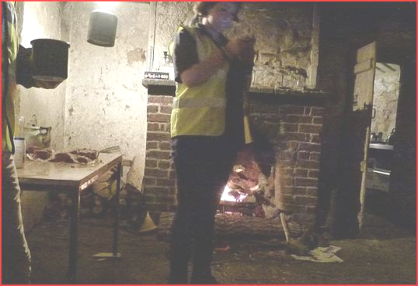
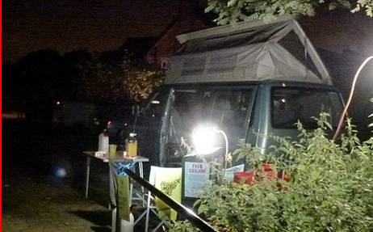

Cumberland Cottage cp The final cp – a campervan at Whiteley Green

Bridge 9. Bridge 10. Bridge 11. Energy drifting away I try for a gel. Although I’d consumed a few gels en route, this late gel and my current stomach state meant an unpleasant texture and taste and I gave way to being sick. The earliest time I’d been sick on the BS, normally saved for after finishing! I remember reading about Nicky Spinks’ record 24 hours round in the Lakes – she’d been sick a number of times but just carried on. I wasn’t too worried, just didn’t eat anything else. I was now running on empty. I kept thinking another hiker was catching me behind – it turned out to be the noises of the dark – just fluid in my water bottle bouncing around

I tried the Wood Lanes route again this year. A few people have advised me to stick longer on MiddleWood Way; they may be right. However my poor last section time is more to do with being knackered than route choice. Towers Road walked and jogged and the final A523 section – no one around – no need to sprint (ha ha), but I do jog the last 100m and that’s it, finished.

Steve Jackson, changed and looking fresh gives me a handshake. I pass into the ‘dining room’ for a debrief with a few others including Paul and pose for a photo (how did I look so fresh?). I need to get out the warm room – so I go and sit down on the car park by a tree. A Hiker official asks after my state and ‘Wouldn’t I like to recover indoors with a bacon sandwich?’ My stomach turns. I do get to clap a few hikers as they finish – I like doing that (it’s the Olympic spirit – cheer everything). Hobble to the car for the briefest of washes as the cramps try to engulf me but are beaten away by the stiffness. Sleep.

I was surprised not to be buzzed by Steve T whizzing passed – whether on the Jacobs ladder decent or perhaps at the top of Cave Dale so I figured he’d gone by without me noticing. However he actually finished after me – beating Steve by 3 minutes would normally be considered amazing for me but as this was a really slow time Steve had obviously had difficulties en route. I noticed that Charlie Sharp also finished just after me – last year he had easily beaten me carrying a large rucksack with a spare pair of shoes! The earlier heat had obviously taken its toll on a few people’s times this year.

I wander back into the kitchen at 4:30am for a bite. It’s great to listen to those finishing in a time of 16+ hours discussing minor shot cuts. There is however someone uttering “Never again, my body’s had it. That was my last Smithy”. Well I suspect with a few day’s rest he’ll be remembering this iconic event, stepping up his training and entering again – most of us do!

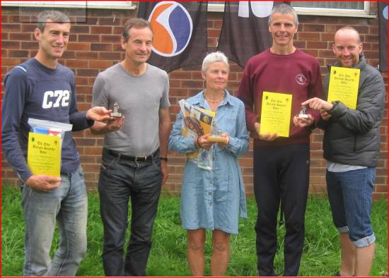
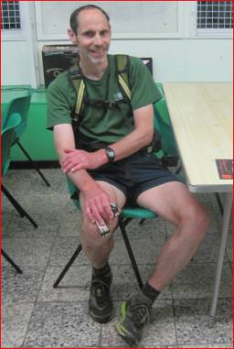
The author just after finishing.

Joint winners in 9:43 are Robin Houghton and Chris Davies
First Lady: Julie Gardner
Julian Brown and Paul Rushworth in the winning Macclesfield Harriers team

Nigel Aston Photo credits: Nick Ham, Paul Rushworth
(9 finishes)

